Name: ____________________________________ Date: _______________________

Writing a Strong Conclusion

Step #1: Reread your draft
- Yasmin almost drowned while boogie boarding because the waves were HUGE after a hurricane
- Yasmin knew the waves were big, but went in the water anyway
- Luckily, the boogie board pushed her out of the water, back towards the shore (saved her life)
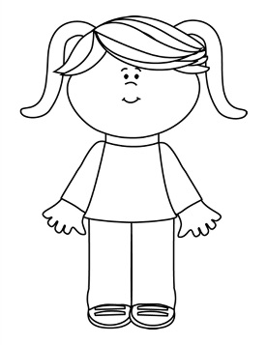
What did I write about?

Step #2: How do I feel?
- Tired because the wave was very strong
- Relieved because I made it out alive
- Angry because the lifeguards didn’t save her
- Embarrassed that she had trouble boogie boarding because she thought she could handle it in the beginning
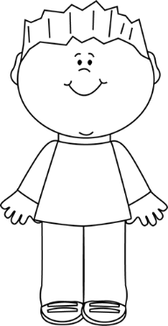
How do I feel?

Step #3: Write your conclusion
Wow! What a day! I was so relieved to have survived the enormous wave thanks to my boogie board. It practically saved my life! I couldn’t believe that the lifeguards didn’t come to save me! Next year, I will definitely go to the beach, but will be much more careful when deciding what to do while I’m there.

